**ASSIGNMENT 1**

1.

using System;

using System.IO;

class Calculator

{

public static void Main(string[] args)

{

Console.WriteLine("Enter first number");

int a = Convert.ToInt32(Console.ReadLine());

Console.WriteLine("Enter second number");

int b = Convert.ToInt32(Console.ReadLine());

Console.WriteLine("Choose an option from the following list:");

Console.WriteLine("Press 1 for Addition");

Console.WriteLine("Press 2 for Subtraction");

Console.WriteLine("Press 3 for Multiplication");

Console.WriteLine("Press 4 for Division");

Console.WriteLine("Enter your choice");

int ch = Convert.ToInt32(Console.ReadLine());

switch (ch)

{

case 1:

Console.WriteLine("Addition of 2 number= {0}", a + b);

break;

case 2:

Console.WriteLine("Subtraction of 2 number = {0}", a - b);

break;

case 3:

Console.WriteLine("Multiplication of 2 number = {0}", a * b);

break;

case 4:

if (a > b || a == b)

Console.WriteLine("Division of 2 number = {0}", a % b);

else if (a < b)

Console.WriteLine("Division of 2 number = {0}", b % a);

break;

default:

Console.WriteLine("Wrong action!! try again");

break;

}

}

}

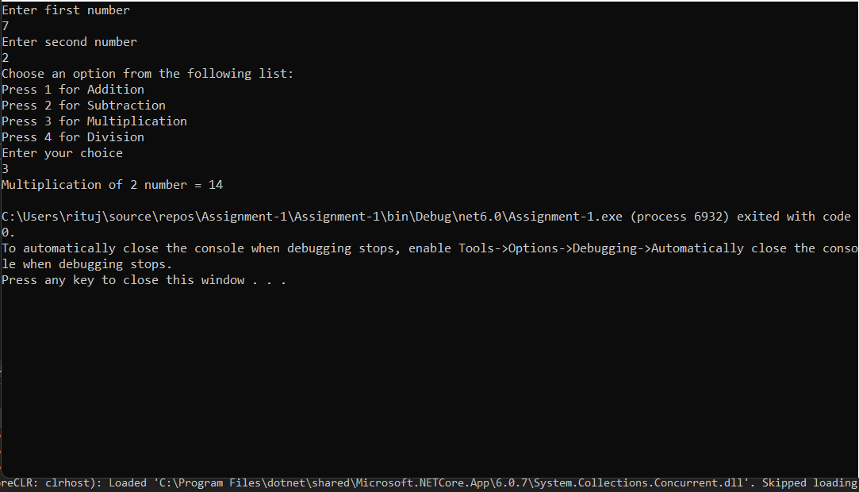

**2.**

using System;

namespace Assignment_1

{

internal class AvgMarks

{

public static void Main(string[] args)

{

try

{

student();

static void student()

{

double std1, std2, std3, std4, std5, highestmarks;

Console.WriteLine("Enter the marks of student1:");

std1 = Convert.ToDouble(Console.ReadLine());

Console.WriteLine("Enter the marks of student2:");

std2 = Convert.ToDouble(Console.ReadLine());

Console.WriteLine("Enter the marks of student3:");

std3 = Convert.ToDouble(Console.ReadLine());

Console.WriteLine("Enter the marks of student4:");

std4 = Convert.ToDouble(Console.ReadLine());

Console.WriteLine("Enter the marks of student5:");

std5 = Convert.ToDouble(Console.ReadLine());

double average = (std1 + std2 + std3 + std4 + std5) / 5;

Console.WriteLine("The average marks of five students {0},{1},{2},{3},{4} is:{5}", std1, std2, std3, std4, std5, average);

if (std1 > std2 && std1 > std3)

highestmarks = std1;

else if (std2 > std1 && std2 > std3)

highestmarks = std2;

else if (std3 > std2 && std3 > std4)

highestmarks = std3;

else if (std4 > std3 && std4 > std5)

highestmarks = std4;

else

highestmarks = std5;

Console.WriteLine("Highest marks among {0},{1},{2},{3},{4} is:{5}", std1, std2, std3, std4, std5, highestmarks);

}

}

catch (Exception ex)

{

Console.WriteLine(ex.Message);

}

Console.ReadKey();

}

}

}

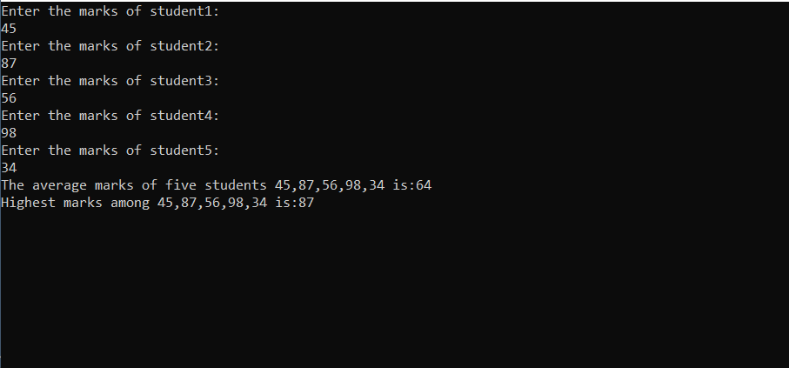

3.

using System;

namespace Assignment_1

{

internal class ParamArray

{

public static int add(params int[] allnumber)

{

int sum = 0;

foreach (int n in allnumber)

{

sum = sum + n;

}

return sum;

}

}

}

Client program

Using System;

namespace Assignment_1

{

class client

{

public static void Main(string[] args)

{

try

{

int sum;

// passing three parameters

sum = ParamArray.add(1, 2, 3);

Console.WriteLine("Sum of 1,2,3 is:\t{0}", sum);

// passing five parameters

sum = ParamArray.add(3, 5, 2, 6, 2);

Console.WriteLine("Sum of 3,5,2,6,2 is:\t{0}", sum);

ParamArray.add();

Console.ReadLine();

}

catch (Exception ex)

{

Console.WriteLine(ex.Message);

}

Console.ReadKey();

}

}

}

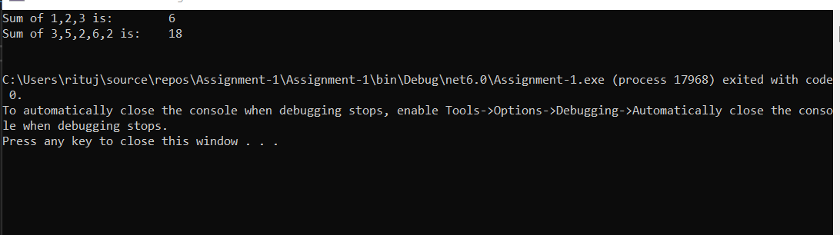

4.

using System;

public class Swap

{

public static void Main(string[] args)

{

int number1, number2, temp;

Console.Write("\nEnter the First Number : ");

number1 = int.Parse(Console.ReadLine());

Console.Write("\nEnter the Second Number : ");

number2 = int.Parse(Console.ReadLine());

temp = number1;

number1 = number2;

number2 = temp;

Console.Write("\nAfter Swapping");

Console.Write("\nFirst Number : " + number1);

Console.Write("\nSecond Number : " + number2);

Console.Read();

}

}

Client program

using System;

namespace Assignment_1

{

class Client1

{

public static void Main(string[] args)

{

try

{

Swap.Main(args);

}

catch (Exception ex)

{

Console.WriteLine(ex.Message);

}

Console.ReadKey();

}

}

}

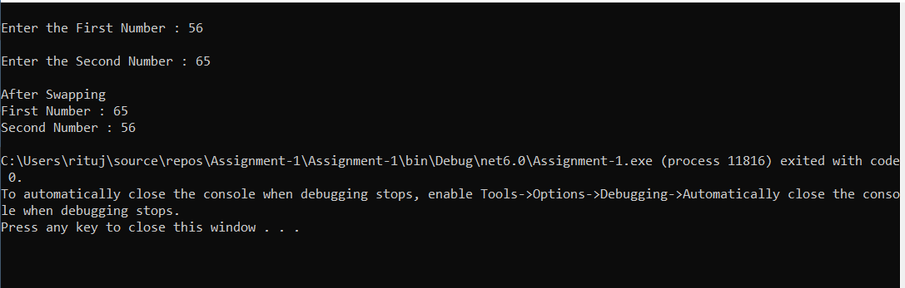

5.

using System;

namespace Assignment_1

{

class Circle

{

public static void Main(string[] args)

{

const double pi = 3.14;

Console.WriteLine("Enter Radius: ");

int r = int.Parse(Console.ReadLine());

double area = pi * r * r;

double circumference = 2 * pi * r;

Console.WriteLine("Area of the circle is " + area);

Console.WriteLine("Circumference of the circle is " + circumference);

Console.ReadKey();

}

}

}

Client program

using System;

namespace Assignment_1

{

class ClientCircle

{

public static void Main(string[] args)

{

try

{

Circle.Main(args);

}

catch (Exception ex)

{

Console.WriteLine(ex.Message);

}

Console.ReadKey();

}

}

}

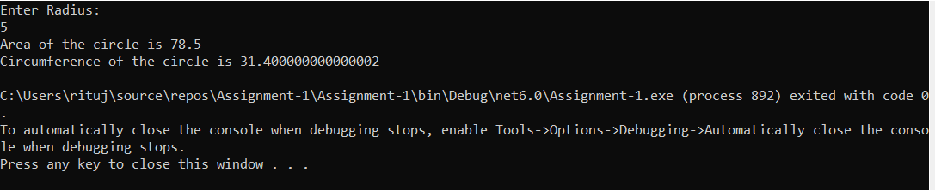

6.

using System;

namespace Books

{

struct Book

{

public int bookId;

public string title;

public double price;

public int code;

enum bookType

{

Magazine = 0,

Novel = 1,

ReferenceBook = 2,

Miscellaneous = 3

}

public void Accept()

{

Console.WriteLine("Enter the Book Id:");

bookId = int.Parse(Console.ReadLine());

Console.WriteLine("Enter the Title:");

title = (Console.ReadLine());

Console.WriteLine("Enter the Price:");

price = int.Parse(Console.ReadLine());

Console.WriteLine("Enter the code for Book Type:");

code = int.Parse(Console.ReadLine());

}

public void Display()

{

Console.WriteLine("\n----------Details----------");

Console.WriteLine("Book Id : " + bookId);

Console.WriteLine("Book Title : " + title);

Console.WriteLine("Book Price : " + price);

Console.WriteLine("Book Type is:" + (bookType)code);

}

static void Main(string[] args)

{

Book book1 = new Book();

book1.Accept();

book1.Display();

}

}

}

